Smart AI Airlines System
A Report Submitted

In The Partial Fulfilment of Requirement for the Degree of BACHELOR OF TECHNOLOGY

Ayush Yadav | 202210101150081

Project Guide: Er. Manish Kumar Srivastava
to the

FACULTY OF COMPUTER SCIENCE & ENGINEERING INSTITUTE OF TECHNOLOGY
SHRI RAMSWAROOP MEMORIAL UNIVERSITY


April, 2026

CERTIFICATE

It is certified that the work contained in the project report titled “Smart AI Airlines System”, diligently prepared by “Ayush Yadav (202210101150081” has been carried out under my supervision with utmost sincerity, and that this work has not been submitted elsewhere for any other degree.

Er. Manish Kumar Srivastava
Project Guide
Department of Computer Science and Engineering
Shri Ramswaroop Memorial University

Dr Shobhit Sinha
Head Of Department
Department of Computer Science and Engineering
Shri Ramswaroop Memorial University

April 2026

DECLARATION

We, Ayush Yadav(202210101150081) student of Bachelor of Technology, Computer Science & Engineering department at Shri Ramswaroop Memorial University, Lucknow hereby declare that the work presented in this project titled "Smart AI Airlines System" is outcome of our own work, is Bonafide, correct to the best of our knowledge and this work has been carried out taking care engineering ethics. We have completely taken care in acknowledging the contribution of others in this academic work. We further declare that in case of any violation of intellectual property rights or copyrights found at any stage, we as the candidates will be solely responsible for the same.

Date:24/04/2026 Ayush Yadav (202210101150081)
Place: SRMU

ACKNOWLEDGEMENT

I would like to take this opportunity to express my heartfelt gratitude to my guide, Er. Manish Kumar Srivastava, for his constant support, valuable guidance, and encouragement throughout the development of this project. His insightful suggestions, patience, and continuous motivation played a crucial role in shaping my work and helping me stay focused. The knowledge and experience I gained under his guidance will continue to inspire me in my future endeavors.
I am also sincerely thankful to Mrs. Anjali Awasthi for her kind support and meaningful contributions. Her suggestions and feedback significantly enhanced the overall quality and direction of this project, making it more structured and effective.
Furthermore, I would like to express my deep appreciation to the Head of the Department, respected faculty members, and my peers for their cooperation, encouragement, and valuable inputs at different stages of this work. Their guidance and support created a positive learning environment that made this project possible.
Lastly, I am grateful to everyone who directly or indirectly contributed to the successful completion of this project. Their support and encouragement have been truly invaluable.

ABSTRACT

The Smart AI Airlines System is an innovative and intelligent desktop-based airline reservation application developed to transform the traditional flight booking experience into a more interactive, efficient, and user-centric process. This system combines the power of modern graphical user interfaces with artificial intelligence to deliver a seamless and automated solution for airline management and ticket reservation.
The application is built using Python and leverages multiple technologies, including Tkinter for designing an intuitive and visually appealing GUI, MySQL for robust database management, and additional libraries such as FPDF for automated ticket generation and QR code integration for modern digital payments. The system is structured to handle core airline operations such as displaying available flights, checking seat availability in real-time, and enabling users to book tickets efficiently.
A key highlight of this project is the integration of an AI-powered chatbot that enhances user interaction. Unlike conventional systems, the chatbot enables users to communicate in natural language, making the booking process more conversational and user-friendly. It can interpret queries such as searching for flights, identifying the cheapest options, checking flight details, and guiding users step-by-step through the reservation process.
The system also incorporates a simulated secure payment gateway that supports both card-based and UPI transactions, providing a realistic and smooth transaction experience. After successful booking and payment, the system automatically generates a digital e-ticket in PDF format, which includes passenger details, flight information, and payment summary. Additionally, the integration of QR code-based payment functionality reflects modern digital transaction trends and adds convenience for users.
From a technical perspective, the project demonstrates the effective use of event-driven programming, modular code design, and database connectivity. It also highlights the practical implementation of Natural Language Processing (NLP) concepts in a real-world application.
Overall, the Smart AI Airlines System aims to provide a smarter, faster, and more efficient airline booking solution by minimizing manual effort and enhancing user experience. The project also demonstrates how artificial intelligence can be integrated into real-world systems to make them more intelligent, responsive, and user-friendly.

INDEX
TABLE OF CONTENTS
CHAPTERS | PAGE NO.
CERTIFICATE | i
DECLARATION | ii
ACKNOWLEDGEMENT | iii
ABSTRACT | iv
TABLE OF CONTENT | v - vi
LIST OF FIGURES | vii
LIST OF TABLES | viii
CHAPTER I: INTRODUCTION | 1-2
1.1 ABOUT THE PROJECT | 1
1.2 PREFACE | 2
1.3 DEFINITION OF PROJECT TECHNOLOGY | 2
CHAPTER II: REQUIREMENTS ANALYSIS AND FEASIBILITY STUDY | 5-8
2.1 REQUIREMENTS ANALYSIS | 5
2.1.1 FUNCTIONAL REQUIREMENTS | 5
2.1.2 NON FUNCTIONAL REQUIREMENTS | 6
2.1.3 HARDWARE REQUIREMENTS | 6
2.1.4 SOFTWARE REQUIREMENTS | 7
2.1.5 CONSTRAINTS | 7
2.2 FEASIBILITY STUDY | 8
2.2.1 TECHNICAL FEASIBILITY | 8
2.2.2 ECONOMICAL FEASIBILITY | 8
2.2.3 OPERATIONAL FEASIBILITY | 9
2.2.4 TIME FEASIBILITY | 8
2.2.4 LEGAL FEASIBILITY | 8
CHAPTER III: SYSTEM ANALYSIS AND DESIGN | 9-14
3.1 SYSTEM ANALYSIS | 9
3.2 SYSTEM DESIGN | 10
3.2.1 USE CASE DIAGRAM | 11
3.2.2 E-R DIAGRAM | 11
3.2.3 DATA FLOW DIAGRAM | 12

3.2.4 CLASS DIAGRAM | 13
3.2.5 SNAP SHOTS | 14
CHAPTER IV: TESTING | 18-20
4.1 ABOUT THE TECHNOLOGY USED | 18
4.2 TESTING | 19
4.2.1 UNIT TESTING | 19
4.2.2 INTEGRATION TESTING | 20
4.2.3 SYSTEM TESTING | 20
CHAPTER V: ADVANTAGES AND LIMITATIONS OF  THE DEVELOPED SYSTEM | 21-23
5.1 ADVANTAGES OF DEVELOPED SYSTEM | 21
5.2 LIMITATIONS OF DEVELOPED SYSTEM | 23
CHAPTER VI: CONCLUSION AND SUGGESTIONS FOR  FURTHER WORK | 26
6.1 CONCLUSION | 26
6.2 SUGGESTIONS FOR FURTHER WORK | 26
REFERENCES | 29

LIST OF FIGURES

ID | Title | Page No.
3.1 | Use case diagram | 11
3.2 | E-R diagram | 12
3.3 | Data flow diagram | 12
3.4 | Class diagram | 13
3.5 | Snap Shots | 14-17

LIST OF TABLES

ID | Title | Page No.
2.1 | Functional Requirements | 5
2.1 | Non-Functional Requirements | 6
2.3 | Hardware Requirements | 6
2.4 | Hardware Requirements | 7
2.5 | Constraints | 7

CHAPTER I: INTRODUCTION

  - ABOUT THE PROJECT
Project Title: Smart AI Airlines System
The Smart AI Airlines System is an advanced, intelligent desktop application developed to transform the traditional flight booking experience into a smart, automated, and user-centric system. In an era where digital solutions are rapidly replacing manual processes, this project focuses on integrating Artificial Intelligence (AI), intuitive user interface design, and real-time database management to create a seamless airline reservation platform. Conventional airline booking systems often require users to navigate through multiple steps, search filters, and forms, which can be time-consuming and confusing, especially for non-technical users. To address these challenges, this project introduces a dual-mode interaction system—a standard booking interface along with an AI-powered conversational assistant. This chatbot is capable of understanding user queries written in simple natural language, such as “Show me flights to Mumbai”, “Which is the cheapest flight?”, or “Book flight 102”. By doing so, it eliminates complexity and makes the system more accessible, interactive, and efficient.
The project is developed using Python programming language, with Tkinter for building a responsive and visually appealing Graphical User Interface (GUI). For backend operations, MySQL database is used to store and manage flight-related information such as flight numbers, ticket prices, seat availability, origin, destination, and flight type. The system ensures real-time data synchronization, meaning that whenever a booking is made, the seat availability is instantly updated in the database.
One of the key highlights of this system is its integrated payment gateway simulation, which provides users with multiple payment options including Credit/Debit Card and UPI (Unified Payments Interface). To enhance convenience, the system also supports QR code-based payments, allowing users to quickly complete transactions using mobile payment applications. After successful payment, the system automatically generates a professional PDF-based e-ticket and receipt, which includes all booking details such as passenger name, flight information, and payment summary.
Additionally, the project incorporates basic Natural Language Processing (NLP) techniques using pattern matching and keyword recognition to analyze user queries and provide accurate responses. While not based on complex deep learning models, this approach effectively demonstrates how AI can be implemented in real-world applications to improve user interaction.
From a broader perspective, this project aims to showcase how emerging technologies can be applied in the aviation sector to improve efficiency, accuracy, and user satisfaction. It reduces manual effort, minimizes errors, and provides a faster booking experience. The system is designed with scalability in mind, meaning it can be further enhanced in the future with advanced AI models, real-time APIs, and web or mobile deployment.
In conclusion, the Smart AI Airlines System is not just a booking application, but a step towards intelligent automation in airline services, demonstrating the practical implementation of AI-driven solutions in solving real-world problems.

1.2 PREFACE
The development of technology has significantly transformed the way industries operate, and the aviation sector is no exception. With the increasing demand for faster, smarter, and more efficient services, there is a growing need for intelligent systems that can simplify complex processes such as flight booking and customer interaction. This project, titled “Smart AI Airlines System”, is an effort to contribute to this transformation by integrating modern technologies into a practical, real-world application.
The primary purpose of this project is to design and develop a system that not only performs basic airline reservation tasks but also enhances user experience through the use of Artificial Intelligence and automation. By incorporating an AI-based chatbot, the system enables users to interact in a more natural and convenient manner, reducing dependency on traditional, form-based booking methods.
This project has been developed as part of the final year curriculum to bridge the gap between theoretical knowledge and practical implementation. It reflects the application of concepts learned in areas such as programming, database management, user interface design, and artificial intelligence. Throughout the development process, emphasis has been placed on creating a system that is not only functional but also user-friendly, efficient, and innovative.
The report presents a detailed overview of the system, including its design, implementation, features, and outcomes. It also highlights the learning experience gained during the development of the project, along with the challenges faced and solutions implemented.
Overall, this project serves as a stepping stone towards understanding how intelligent systems can be built and applied in real-world scenarios to improve efficiency and user satisfaction.

1.3 DEFINITION OF PROJECT TECHNOLOGY
The Smart AI Airlines System is developed using a combination of modern software technologies that work together to create an efficient, interactive, and intelligent application. Each technology used in this project plays a specific role in ensuring smooth functionality, user interaction, and data management. The following are the key technologies used in this project along with their definitions:

1.Python (Programming Language)
Python is a high-level, interpreted programming language known for its simplicity and readability. It is widely used for developing applications in fields such as web development, data science, and artificial intelligence. In this project, Python is used as the core programming language to implement the entire system logic, including booking operations, chatbot functionality, and payment processing.
2 Tkinter (Graphical User Interface - GUI)
Tkinter is a standard GUI library in Python used to create desktop applications with windows, buttons, text fields, and other visual elements.
In this project, Tkinter is used to design an interactive and user-friendly interface, allowing users to easily navigate through flight booking and chatbot features.
3 MySQL (Database Management System)
MySQL is an open-source relational database management system used to store and manage structured data. In this system, MySQL is used to store flight details such as flight number, price, available seats, origin, and destination, and it ensures real-time updates whenever a booking is made.
4 PyMySQL (Database Connectivity Library)
PyMySQL is a Python library that enables communication between Python applications and MySQL databases. It is used in this project to execute queries, retrieve flight data, and update seat availability dynamically.
5 Artificial Intelligence (AI)
Artificial Intelligence refers to the simulation of human intelligence in machines, enabling them to perform tasks such as understanding language, learning, and decision-making.
In this project, AI is implemented through a chatbot assistant that interacts with users, understands their queries, and helps in searching and booking flights.
6 Natural Language Processing (NLP)
Natural Language Processing is a branch of AI that allows computers to understand and interpret human language.The project uses basic NLP techniques such as keyword recognition and pattern matching to analyze user input and provide relevant responses in the chatbot.
7 FPDF (PDF Generation Library)
FPDF is a Python library used to generate PDF files programmatically.
In this system, it is used to create a digital ticket (E-ticket) after successful booking, which includes passenger and payment details.
8 QR Code Technology
QR Code (Quick Response Code) is a machine-readable code used for storing information that can be scanned using a smartphone. In this project, QR codes are generated for UPI-based payments, allowing users to complete transactions quickly and conveniently.
9 PIL (Python Imaging Library)
PIL (Pillow) is a Python library used for image processing. It is used here to handle and display QR code images within the application interface.
10 Regular Expressions (Regex)
Regular Expressions are patterns used to match and manipulate text.
In this project, regex is used in the chatbot to identify keywords, extract flight numbers, and interpret user queries effectively.
The integration of these technologies enables the Smart AI Airlines System to function as a complete, intelligent, and user-friendly application. Each component contributes to enhancing performance, automation, and user experience, making the system a practical example of modern software development and AI implementation.

CHAPTER II: REQUIREMENTS ANALYSIS AND FEASIBILITY STUDY

2.1 REQUIREMENTS ANALYSIS
The Requirements Analysis phase defines the overall functionality and performance expectations of the Smart AI Airlines System. It ensures that the system is developed according to user needs and operates efficiently. This phase includes functional requirements, non-functional requirements, hardware and software requirements, and system constraints.
2.1.1 Functional Requirements
Functional requirements describe the specific features and operations that the system must perform. These requirements focus on user interaction, system behavior, and core functionalities such as booking, payment, and data management.
S. No. | Module | Requirement Description
1 | Flight Management | Display all flights with details such as flight number, price, seats, origin, destination, and type
2 | Booking System | Allow users to book tickets after entering personal details
3 | AI Chatbot | Understand user queries and assist in flight search and booking
4 | Payment System | Provide Card and UPI payment options with validation
5 | QR Code Generation | Generate QR code for quick UPI payments
6 | Ticket Generation | Generate PDF ticket with booking details
7 | Database Operations | Fetch and update flight data in real-time
Table 2.1 Functional Requirements
The system allows users to view available flights and select one for booking. It verifies seat availability before confirming the reservation and updates the database after booking. The AI chatbot enables users to interact using simple language, making the system more user-friendly. The payment system supports multiple options, and after successful payment, a PDF ticket is generated automatically.
2.1.2 Non-Functional Requirements
Non-functional requirements define the quality attributes and performance standards of the system. These requirements ensure that the system is efficient, secure, reliable, and easy to use.
S.No | Category | Requirement Description
1 | Performance | Fast response time and efficient processing
2 | Usability | Simple and user-friendly interface
3 | Security | Input validation and safe data handling
4 | Reliability | Stable performance with minimal errors
5 | Scalability | Ability to add new features in future
Table 2.2 Non-Functional Requirements
The system should provide quick responses and smooth performance. It must be easy to use for all types of users. Security measures such as input validation are necessary to prevent errors. The system should be reliable and capable of handling unexpected situations. It should also be scalable to allow future enhancements.
2.1.3 Hardware Requirements
Hardware requirements specify the physical components needed to run the system efficiently.

S.No | Component | Specification
1 | RAM | Minimum 4 GB
2 | Processor | Dual-core or higher
3 | Storage | Minimum 500 MB free space
4 | Input | Keyboard and Mouse
Table 2.3 Hardware Requirements
These requirements ensure smooth execution of the application without performance issues.

2.1.4 Software Requirements
Software requirements define the tools and technologies required for the development and execution of the system.

S.No | Software/Tool | Purpose
1 | Python 3.x | Core programming language
2 | Tkinter | GUI development
3 | MySQL | Database management
4 | PyMySQL | Database connectivity
5 | FPDF | PDF generation
6 | qrcode | QR code generation
7 | Pillow | Image processing
Table 2.4 Software Requirements
These software tools are essential for building different components of the system. Python handles logic, Tkinter manages the interface, MySQL stores data, and additional libraries provide features like PDF generation and QR code creation.

2.1.5 Constraints
Constraints define the limitations under which the system operates.
S. No. | Constraint | Description
1 | Platform Limitation | Desktop-based system only
2 | Payment System | Simulated, not real-time
3 | AI Capability | Uses basic NLP techniques
4 | Database Dependency | Requires local MySQL setup
Table 2.5 Constraints

2.2. Feasibility Study
The Feasibility Study evaluates whether the project is practical, achievable, and beneficial. It analyzes different aspects such as technical capability, cost, usability, and time requirements. This section explains different types of feasibility that determine the success of the project.
2.2.1 Technical Feasibility:
The technologies used are reliable, widely available, and easy to implement, ensuring smooth development.
2.2.2 Economic Feasibility:
The project requires minimal investment since all tools and libraries used are free and open-source.
2.2.3 Operational Feasibility:
The system is designed with a simple interface, making it easy for users to operate without technical expertise.
2.2.4 Time Feasibility:
The project can be completed within the given timeframe with proper planning and execution.
2.2.5 Legal Feasibility:
The system does not involve real financial transactions or sensitive data, ensuring compliance with legal standards.
The Requirements Analysis and Feasibility Study confirm that the Smart AI Airlines System is well-planned, practical, and achievable. The system meets user requirements while maintaining performance, usability, and reliability. It is cost-effective and scalable, making it suitable for both academic and real-world applications.

CHAPTER III: SYSTEM ANALYSIS AND DESIGN

3.1 SYSTEM ANALYSIS
System Analysis is an essential phase in software development that focuses on understanding the existing system, identifying its limitations, and designing an improved solution that meets user needs more efficiently. In the context of the Smart AI Airlines System, system analysis involves examining traditional airline booking methods and identifying areas where automation and intelligence can enhance performance and user experience. The existing systems are often manual or semi-digital, requiring users to go through multiple steps such as searching for flights, filling forms, and confirming bookings, which can be time-consuming and prone to errors. These systems usually lack intelligent assistance, making it difficult for users—especially non-technical ones—to interact smoothly. To overcome these challenges, the proposed Smart AI Airlines System introduces a modern, automated approach that integrates a user-friendly graphical interface with an AI-based chatbot. This allows users to either manually book flights or interact with the system using natural language queries such as searching for flights, checking availability, or making bookings. The system is designed to retrieve real-time data from a MySQL database, ensuring accurate information about flight details and seat availability.
The main objective of the system is to simplify the booking process, reduce manual effort, and enhance user interaction through intelligent automation. The scope of the system is limited to a desktop-based application operating in a local environment, but it provides a strong foundation for future expansion into web or mobile platforms with real-time integrations. The system consists of key components such as the GUI for user interaction, an AI chatbot for assistance, a database for data storage, backend logic for processing, and modules for payment and ticket generation. The overall process includes searching for flights, selecting a flight, entering user details, verifying seat availability, completing payment, and generating a ticket. This structured flow ensures efficiency and reliability. The proposed system offers several advantages, including faster booking, reduced errors, improved user experience, and intelligent interaction. In conclusion, the system analysis clearly demonstrates that the Smart AI Airlines System is a well-designed solution that addresses the shortcomings of traditional systems while providing a modern, efficient, and user-friendly approach to airline booking.

3.2 SYSTEM DESIGN
System Design is the process of converting system requirements into a structured form. It defines how the system will work, including its architecture, components, and data flow.
3.2.1 USE CASE DIAGRAM
A Use Case Diagram represents the interaction between users (actors) and the system.
Actors:
- User (Passenger)
- Admin
Use Cases:
- Register/Login
- Search Flights
- Book Ticket
- Cancel Ticket
- Make Payment
- Get AI Recommendations
- Book Ticket with AI Assitant
- Manage Flights (Admin)
Description:
The user interacts with the system to search and book flights, while the admin manages flight data and system operations. The AI features enhance user experience by providing smart booking and support.

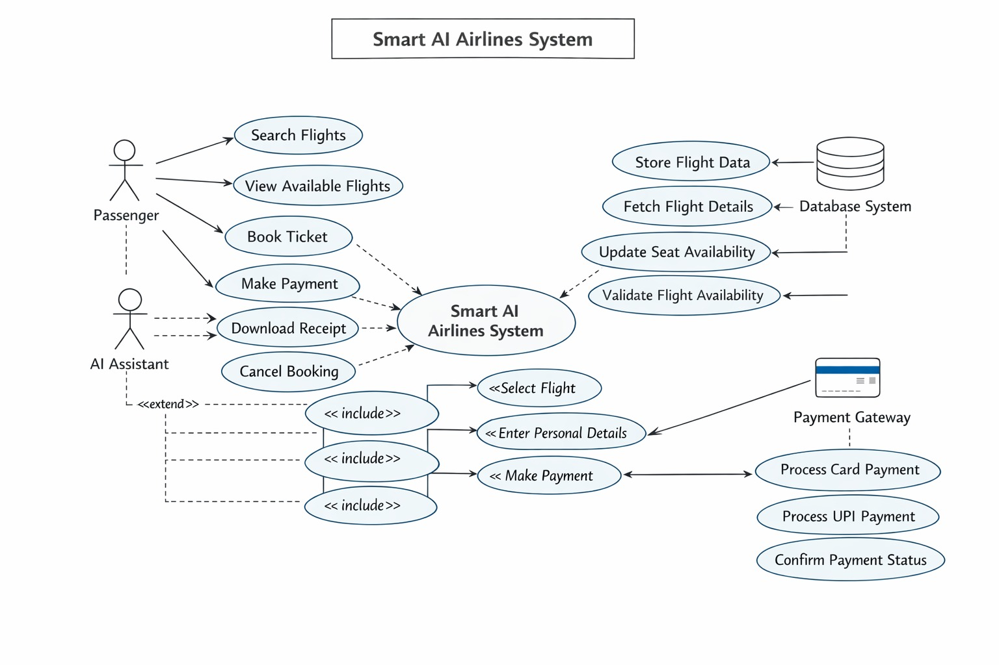
Figure 3.1 – Use Case Diagram of Smart AI Airlines System

3.2.2 E-R DIAGRAM
An Entity-Relationship (E-R) Diagram represents the relationship between different data entities.
Entities:
- User: Stores user details (ID, Name, Email)
- Flight: Stores flight information
- Booking: Stores booking details
- Payment: Stores transaction details
Relationships:
- One user can make multiple bookings
- One flight can have multiple bookings
- Each booking has one payment
Description:
The ER diagram helps in organizing data efficiently and ensures proper relationship management between entities in the system
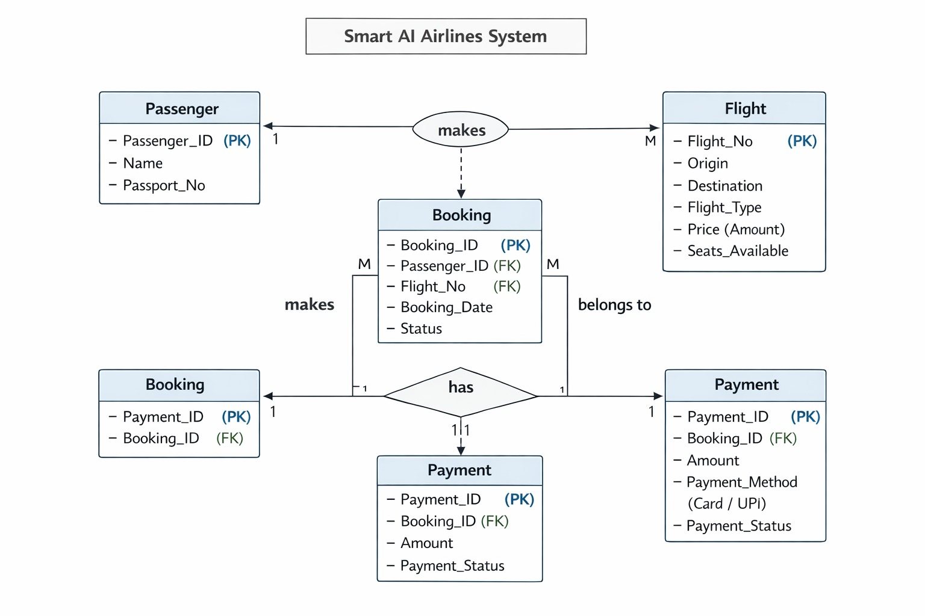
Figure 3.2 – ER Diagram of Smart AI Airlines System

3.2.3 DATA FLOW DIAGRAM
A Data Flow Diagram (DFD) shows how data flows within the system.
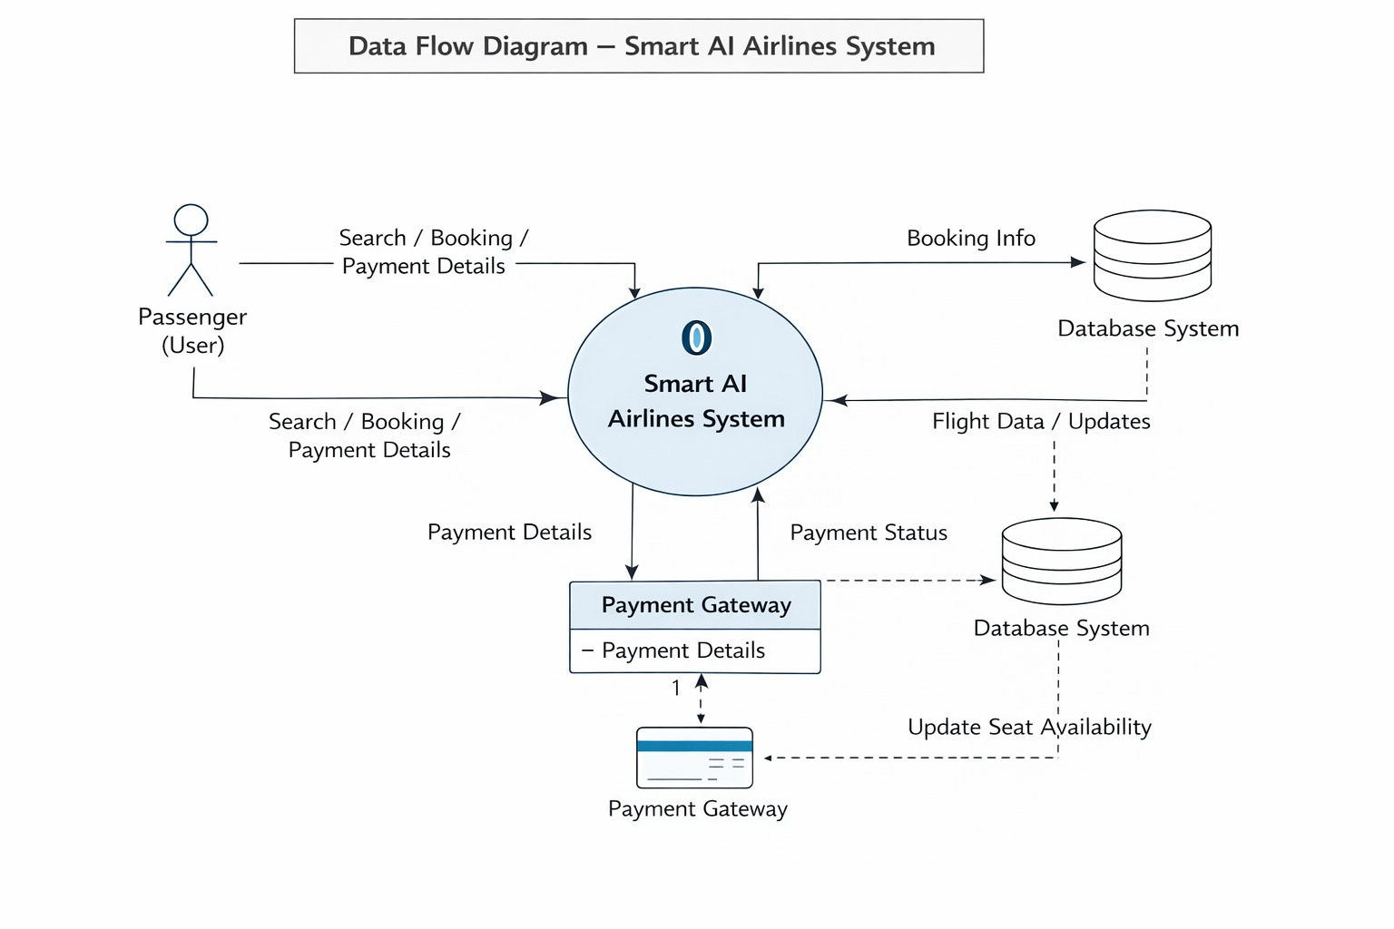
Figure 3.3 - Data Flow Diagram Of Smart AI Airlines System

Level 0 :
Represents the entire system as a single unit interacting with users and admin.
Level 1:
Breaks the system into processes like:
- Login System
- Flight Search
- Booking System
- Payment Processing
Description:
DFD helps in understanding how data is processed and transferred within the system, ensuring smooth workflow.
3.2.4 CLASS DIAGRAM
A Class Diagram represents the structure of the system using classes, attributes, and methods.
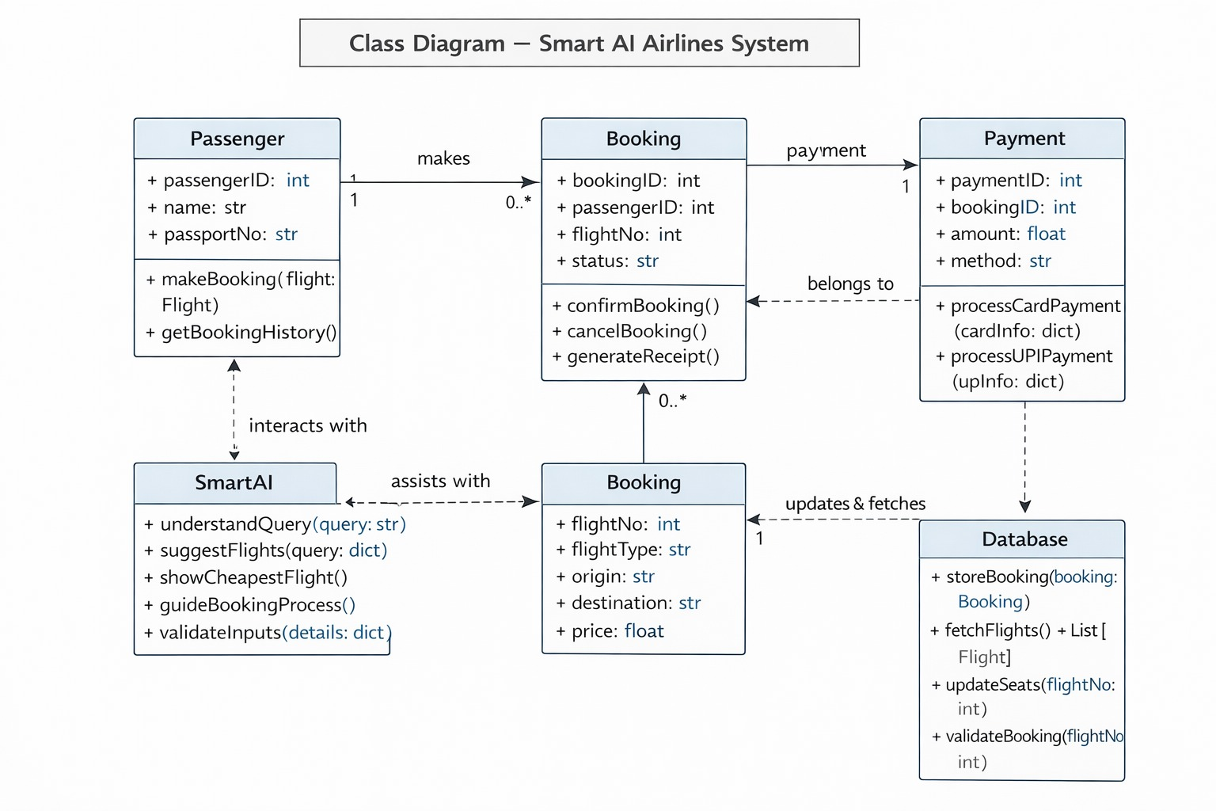
Figure 3.4 - UML Class Diagram of Smart AI Airlines System

Main Classes:
- User Class: userID, name, login()
- Flight Class: flightID, schedule, getDetails()
- Booking Class: bookingID, createBooking()
- Payment Class: paymentID, processPayment()

3.2.5 SNAP SHOT
Snapshots represent screenshots of the system interface.
Examples:
- Flight Search Page
- Booking Page
- Payment Page
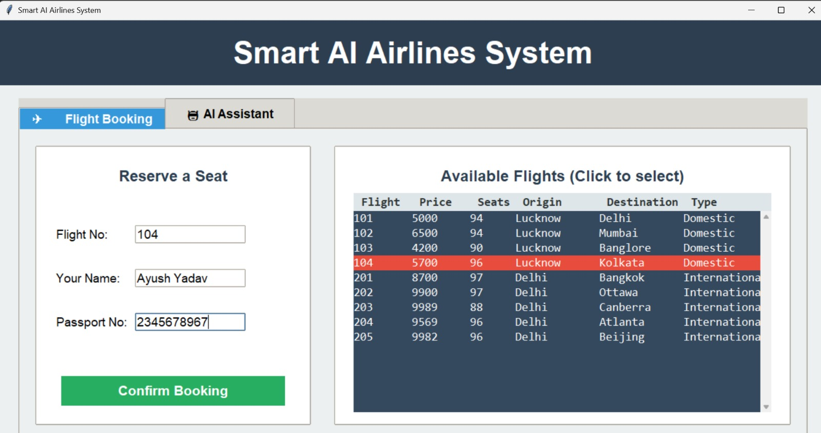
Figure 3.5 - Flight Booking Interface
- This screen displays the flight booking module where users can enter their details and select available flights.
- It provides an easy and user-friendly interface for searching and reserving seats efficiently

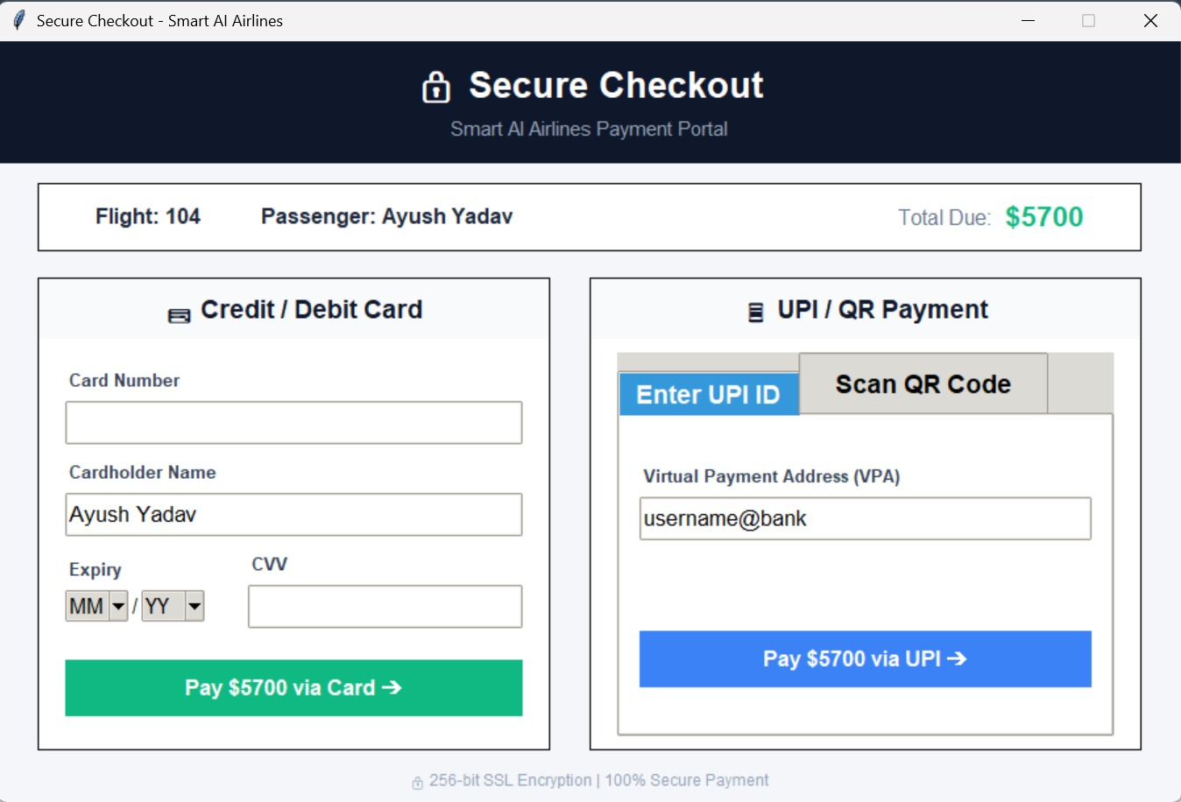
Figure 3.6 - Secure Payment Gateway
  - This screen shows the secure checkout system where users can complete payments using card or UPI methods.

  - It ensures safe and encrypted transactions with multiple payment options for user convenience.

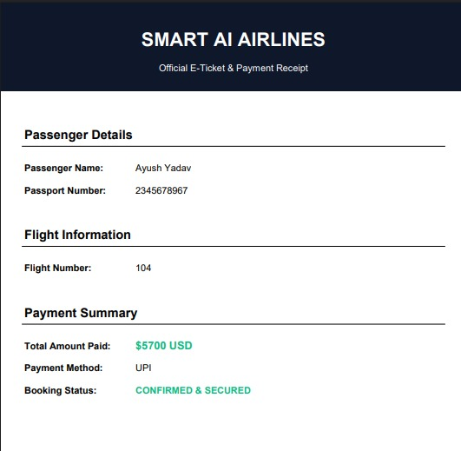
Figure 3.7 - E-Ticket and Payment Confirmation
- This screen represents the final booking confirmation along with passenger and payment details.
- It confirms that the ticket has been successfully booked and the payment has been securely processed

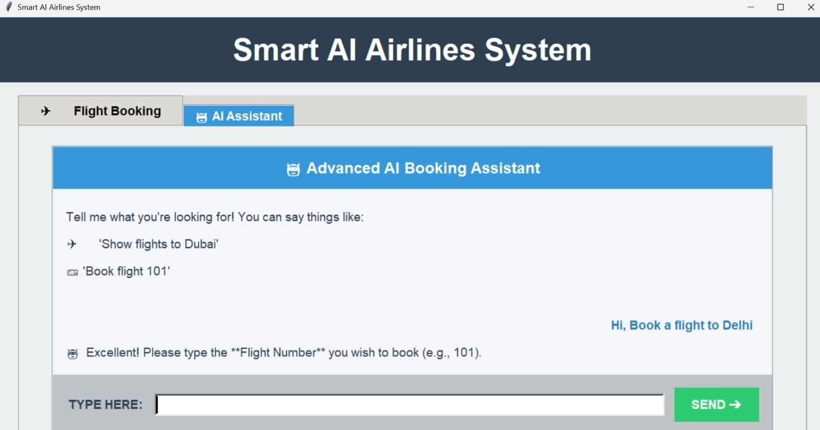
Figure 3.8 - AI Assistant Interface
- This screen shows the AI-based chatbot assistant that helps users in booking flights and answering queries.
- It provides intelligent suggestions and enhances user experience through automated support.

CHAPTER IV: TESTING
4.1 ABOUT THE TECHNOLOGY USED
The Smart AI Airlines System is developed using a combination of modern technologies that ensure efficiency, reliability, and intelligent performance. The system is designed as a desktop-based application and integrates user interface design, backend logic, database management, and basic artificial intelligence features.
1 Frontend Technologies
The frontend of the system is developed using Python Tkinter, which is a standard GUI (Graphical User Interface) library.
- Tkinter is used to design the structure and layout of the application interface
- It provides components such as buttons, labels, text fields, and tabs for user interaction
- It ensures a simple, interactive, and user-friendly interface
This allows users to easily navigate through flight booking and chatbot features.
2 Backend Technologies
The backend of the system is developed using Python.
- Python handles the core logic of the application
- It processes user inputs and manages booking operations
- It controls communication between the interface and the database
- It ensures proper functioning of features like chatbot interaction, booking validation, and payment processing
Python makes the system efficient, flexible, and easy to maintain.
3 Database Management System
The system uses MySQL as the database management system.
- It stores flight details such as flight number, price, seats, origin, and destination
- It maintains booking records and updates seat availability in real-time
- It ensures data consistency, integrity, and fast retrieval
The connection between Python and MySQL is established using the PyMySQL library.
4 Artificial Intelligence Technologies
Artificial Intelligence is implemented in the system through a chatbot assistant.
- The chatbot uses basic Natural Language Processing (NLP) techniques
- It understands user queries such as “show flights”, “cheapest flight”, or “book flight”
- It provides automated responses and guides users step-by-step
- It enhances user experience by making the system interactive
Although simple, this AI component demonstrates practical implementation of intelligent systems.
5. Additional Libraries and Tools
The system also uses additional Python libraries to enhance functionality:
- FPDF is used to generate PDF tickets after booking
- qrcode library is used to generate QR codes for UPI payments
- Pillow (PIL) is used for image processing and displaying QR codes
- Regular Expressions (re) are used to process and analyze user input in the chatbot
These tools help in automating tasks and improving system efficiency.
4.2 TESTING
Testing is a crucial phase in software development that ensures the system works correctly and meets all specified requirements. It involves identifying errors, fixing bugs, and verifying that each component of the system performs as expected.
In the Smart AI Airlines System, testing is performed at multiple levels to ensure accuracy, reliability, and smooth performance. Proper testing improves system quality and enhances user satisfaction.
4.2.1 UNIT TESTING
Unit Testing is the process of testing individual components or modules of the system separately. Each part is tested independently to ensure that it functions correctly.
In this system, unit testing includes checking modules such as user input fields, flight display, chatbot responses, booking logic, and payment validation. For example, the flight search functionality is tested to ensure it retrieves correct data from the database, and the booking module is tested to verify that tickets are generated correctly.
The main purpose of unit testing is to detect errors at an early stage, ensure each module works properly, and simplify the debugging process.
4.2.2 INTEGRATION TESTING
Integration Testing is performed after unit testing and focuses on checking whether different modules of the system work together correctly.
In the Smart AI Airlines System, this includes testing the interaction between the booking system and the database, the connection between chatbot and booking process, and the integration of payment with booking confirmation. It also ensures that data flows correctly between the GUI, backend logic, and database.
The purpose of integration testing is to ensure smooth communication between different components, identify interface errors, and verify combined system functionality.
4.2.3 SYSTEM TESTING
System Testing is the final level of testing where the complete system is tested as a whole.
In this project, system testing includes verifying the complete flight booking process from selecting a flight to generating the ticket. It also checks chatbot responses, payment processing, system performance, and overall user experience.
The purpose of system testing is to validate the entire system, ensure reliability and performance, and confirm that all requirements are fulfilled successfully.

CHAPTER V: ADVANTAGES AND LIMITATIONS OF THE DEVELOPED SYSTEM
5.1 ADVANTAGES OF DEVELOPED SYSTEM
The Smart AI Airlines System provides several advantages over traditional airline booking systems by integrating automation, a graphical user interface, and an AI-based chatbot. The system improves efficiency, accuracy, and user interaction. The major advantages are as follows:
1 Automation of Processes
The system automates key operations such as flight search, seat availability checking, booking confirmation, and ticket generation.
- Reduces manual effort
- Minimizes human errors
- Increases speed and efficiency
Automation ensures that the booking process is smooth and fast.
2 User-Friendly Interface
The system is designed using Tkinter, providing a simple and interactive graphical interface.
- Easy navigation between booking and chatbot sections
- Clear input fields and flight display
- Suitable for both technical and non-technical users
This improves overall user experience.
3 AI-Based Chatbot Assistance
The system includes a chatbot that helps users interact using simple text queries.
- Allows users to search flights using natural language
- Guides users through the booking process
- Provides instant responses
This makes the system more interactive and intelligent.
4 Real-Time Database Updates
The system updates flight data dynamically using a MySQL database.
- Ensures accurate seat availability
- Prevents overbooking
- Provides up-to-date flight information
This improves reliability of the system.
5 Multiple Payment Options (Simulated)
The system supports different payment methods such as Card and UPI (simulated).
- Provides flexibility to users
- Includes QR code-based payment option
- Validates input before processing
This enhances convenience during booking.
6 Automatic PDF Ticket Generation
After successful booking, the system generates a PDF ticket.
- Includes passenger and flight details
- Provides a digital record of booking
- Eliminates manual ticket creation
This improves efficiency and professionalism.
7 Efficient Data Management
The system uses MySQL for storing and managing data.
- Ensures secure storage of flight records
- Enables quick data retrieval
- Maintains data consistency
This supports smooth system operation.
8 Reduced Manual Work
The system reduces dependency on manual processes.
- Automates repetitive tasks
- Improves accuracy
- Saves time
This makes the system efficient and practical.
9 Scalability and Flexibility
The system is designed to handle increasing users and data.
- Can be expanded easily with new features
- Supports growing airline operations
- Flexible for future upgrades
This makes the system future-ready.
10 Better Decision-Making
AI and data analytics help in making informed decisions.
- Predicts passenger demand
- Helps in pricing strategies
- Improves operational planning
This benefits airline management in the long term.
5.2 LIMITATIONS OF DEVELOPED SYSTEM
The Despite its numerous advantages, the Smart AI Airlines System also has certain limitations that need to be considered.
1 Dependence on Internet Connectivity
The system requires a stable internet connection to function properly.
- Users cannot access services without internet
- Real-time features depend on connectivity
This can be a limitation in areas with poor network coverage.
2 High Initial Development Cost
Developing an AI-based system requires investment.
- Cost of software development
- Cost of implementing AI technologies
- Infrastructure setup cost
Although beneficial in the long run, initial costs can be high.
3 Data Security Risks
Handling large amounts of sensitive data involves risks.
- Possibility of cyber-attacks
- Risk of data breaches
- Need for strong security measures
Proper security mechanisms are required to minimize risks.
4 Complexity of AI Implementation
AI technologies can be complex to develop and maintain.
- Requires skilled professionals
- Needs continuous monitoring and updates
- Model accuracy depends on data quality
This increases system complexity.
5 Maintenance and Upgradation Requirements
The system requires regular updates and maintenance.
- Bug fixing and performance improvement
- Updating AI models
- System monitoring
This requires time and resources.
6 Dependency on Technology
The system heavily depends on software and hardware.
- System failure can disrupt operations
- Technical issues may affect services
Backup systems are required to handle failures.
7 Limited Human Interaction
Although AI improves efficiency, it reduces human interaction.
- Some users prefer human support
- AI may not handle complex queries effectively
This can affect user satisfaction in certain cases.
8 Accuracy Limitations of AI
AI systems are not always 100% accurate.
- Predictions may sometimes be incorrect
- Recommendations depend on available data
Continuous improvement is required for better accuracy.

CHAPTER VI - CONCLUSION AND SUGGESTIONS FOR FURTHER WORK

6.1 CONCLUSION
The Smart AI Airlines System is a modern and efficient solution designed to improve the overall functioning of airline operations by integrating Artificial Intelligence and automation. The system successfully addresses the limitations of traditional airline management systems, such as manual errors, slow processing, lack of real-time updates, and inefficient customer service.
This project provides a smart platform where users can easily search flights, book tickets, cancel reservations, and receive real-time updates. The inclusion of AI-based features such as personalized recommendations and chatbot support enhances user experience and ensures quick and efficient service.
The system also benefits airline management by providing better control over flight scheduling, passenger data, and operational activities. With the help of data analysis and prediction, it supports informed decision-making and improves overall efficiency.
Throughout the development process, proper requirement analysis, system design, and testing were carried out to ensure the system is reliable, secure, and user-friendly. The use of modern technologies such as web development tools, databases, and AI techniques makes the system scalable and adaptable to future needs.
In conclusion, the Smart AI Airlines System proves to be an effective, reliable, and innovative solution for airline management. It reduces operational complexity, enhances productivity, and improves customer satisfaction, making it highly suitable for real-world implementation.
6.2 SUGGESTIONS FOR FURTHER WORK
Although the system is efficient and functional, there are several improvements and enhancements that can be implemented in the future to make it more advanced and powerful.
1. Mobile Application Development
A dedicated mobile application can be developed for Android and iOS platforms.
- Provides easy access to users anytime, anywhere
- Improves user convenience and engagement
2. Advanced AI and Predictive Analysis
More advanced AI models can be implemented to improve system intelligence.
- Predict flight delays using weather and traffic data
- Improve recommendation accuracy
- Analyze customer behavior more effectively
3. Voice-Based Chatbot Integration
The chatbot can be enhanced with voice recognition features.
- Allows users to interact using voice commands
- Improves accessibility and user experience
4. Integration with Global Airline Systems
The system can be connected with international airline databases.
- Provides global flight information
- Expands system usability and reach
5. Enhanced Security Features
Security can be further improved using advanced techniques.
- Biometric authentication (fingerprint/face recognition)
- Multi-factor authentication
- Strong encryption methods
6. Real-Time Weather Integration
Integration with weather APIs can improve system accuracy.
- Helps in predicting flight delays
- Provides better travel planning for users
7. Multi-Language Support
The system can support multiple languages.
- Makes it accessible to a wider audience
- Improves usability for non-English users
8. Cloud-Based Deployment
Deploying the system on cloud platforms can improve performance.
- Provides scalability and flexibility
- Ensures data backup and reliability
Conclusion of Future Work
These enhancements can further improve the efficiency, usability, and performance of the Smart AI Airlines System, making it more advanced and competitive in the future.

REFERENCES

The following sources were referred to during the development of the Smart AI Airlines System and preparation of this project report:
Books:
- Books on Python Programming that explain core concepts, GUI development using Tkinter, and practical implementation techniques
- Books on Artificial Intelligence and basic Natural Language Processing that helped in understanding chatbot functionality and user interaction
- Software Engineering and System Design textbooks that provided knowledge about project planning, system analysis, and development methodologies
Websites:
- www.geeksforgeeks.org – Used for understanding Python concepts, database connectivity, and problem-solving techniques
- www.w3schools.com – Referenced for SQL queries, database operations, and basic programming concepts
- www.tutorialspoint.com – Used for learning Tkinter GUI development, MySQL integration, and Python libraries
- docs.python.org – Official Python documentation used for accurate understanding of libraries like Tkinter, re (Regular Expressions), and file handling
Research Papers & Articles:
- Articles related to airline reservation systems to understand how booking systems work in real-world scenarios
- Research papers on AI-based chatbot systems to learn how user queries can be processed and handled intelligently
- Case studies on automation in software systems to understand the importance of reducing manual effort and improving efficiency
Documentation:
- Official documentation of Python libraries such as Tkinter (GUI), PyMySQL (database connectivity), and re (text processing)
- MySQL database documentation for understanding data storage, queries, and real-time updates
- Documentation of additional libraries such as FPDF for PDF generation, qrcode for QR code creation, and Pillow for image processing
Other Sources:
- Online tutorials and coding platforms that provided practical examples and implementation guidance
- Educational videos and technical blogs that helped in understanding project structure and real-world applications
- Hands-on practice and experimentation during development, which contributed significantly to learning and problem-solving
This combination of books, online resources, documentation, and practical implementation helped in successfully developing the Smart AI Airlines System and understanding both theoretical and practical aspects of the project.

